 | YEAR 12 MATHEMATICS SPECIALIST  SEMESTER TWO 2017  QUESTIONS OF REVIEW 8: Sample Means

Name: _______________________

Wednesday 20th September Time: 20 minutes Mark /20
Calculators assumed.

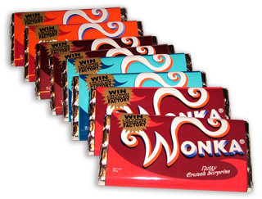
[10 marks – 2, 2, 3 and 3]

Willy Wonka’s wonderful chocolate factory produces bars of fudge that have a mean weight of 35.2 grams and a standard deviation of 0.27 grams.
These bars are packed into boxes of 50.
- Describe the distribution (type, mean and standard deviation) of the average weight of bars in a box.
http://3.bp.blogspot.com/-wiligbYaMsk/T_mfjspr3QI/AAAAAAAAAJ0/2jYIrhn3CgI/s1600/Delight+in+Willy+Wonka+Chocolate+Bars.jpg, accessed 14 September 2017
- What is the probability this average weight is between 35.15 and 35.35 grams?

- Determine a 95% confidence interval for the total weight of the Wonka fudge bars in a box.

- Compare the width of your confidence interval in (c) with the width of a 95% confidence interval for the weight of a display package that contains 20 Wonka fudge bars. Explain.

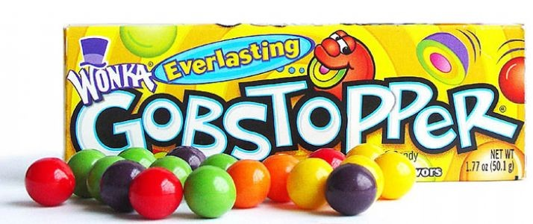
[10 marks – 3, 4 and 3]
10% of the production of Gobstoppers are Orange Outbursts and the Oompa Loompas are putting the Gobstoppers into packs of 30.
They then count 80 packs into each carton for distribution to the wholesalers.
https://www.ruralking.com/media/catalog/product/cache/1/image/9df78eab33525d08d6e5fb8d27136e95/w/o/wonka-s-everlasting-gobstoppers-165-p_ekm_714x300_ekm_.jpg, accessed 14 September 2017

(a) Compare the distributions of the number of Orange Outbursts in a pack with the average number per pack within a carton and highlight all significant differences.

Augustus Gloop is in charge of quality control and prefers large samples to test by eating them all. He finds that, in a carton, the average number of Orange Outbursts per pack is 3.5

(b) Set up a 95% confidence interval for the population mean and decide, with reasons, whether this proportion of Orange Outbursts is consistent with the 10% production figure.

(c) How many packs should be in a carton so that a 99% confidence interval for the population mean of the average number of Orange Outbursts per pack has width 0.5?

